

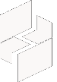

MICROSOFT ARCHITECTURE BEST PRACTICE FOR SECURITY
USECASE: MULTILAYERED (DEFENSE-IN-DEPTH) PROTECTION ARCHITECTURE FOR AZURE VIRTUAL MACHINES (VMS)

Document Title | MULTILAYERED (DEFENSE-IN-DEPTH) PROTECTION ARCHITECTURE FOR AZURE VIRTUAL MACHINES (VMS)
Presales/Technical Head | Tushar Mehrotra/Rohit Pandey
CCoE Lead | Ravishankar N
Creation Date | October 2025
Version | Description | Modified by | Date | Approved by | Date
1 | Initial Architecture design | AJEET KUMAR | 01/10/2025 | Ravi Shankar | 01/10/2025
2 | Reusability & scalability | AJEET KUMAR | 08/10/2025 | Ravi Shankar | 08/10/2025
Contents
1
1. Executive Summary 3
2. Scope and Applicability 3
3. Business Scenario Overview 3
4. Reference Architecture Overview 3
4.1 Architecture Description 4
5. Logical Architecture Components 4
5.1 Identity and Access Layer 4
5.2 Privileged Access Management Layer 5
5.3 Network Access Layer 5
5.4 Just-In-Time (JIT) VM Access Layer 5
5.5 Authorization and Governance Layer 5
5.6 Secrets and Credential Management 5
6. Cloud Center of Excellence (CCoE) Enablement Model 5
7. Reusability and Scalability 6
8. Conclusion 6

1. Executive Summary
This document is based on a multi layered (defense-in-depth) protection architecture for Azure Virtual Machines (VMs). The objective is to secure administrative and operational access to VMs while minimizing the attack surface and ensuring compliance with enterprise security standards.
The architecture aligns with Microsoft security principles of secure by design, secure by default, and secure operations.

2. Scope and Applicability
This reference architecture applies to:
- Azure IaaS Virtual Machines (Windows and Linux)
- Administrative, operational, and privileged access scenarios
- Enterprise, mid-market, and regulated industry workloads
- Zero Trust and least-privilege-based security models
- CSP, enterprise IT, and CCoE governed Azure environments

3. Business Scenario Overview
Organizations periodically require administrative access to Azure VMs for:
- Incident and outage troubleshooting
- Security investigations and remediation
- Critical operating system patching and system maintenance
Conventional approaches often expose management ports such as RDP (3389) and SSH (22) to the public internet, significantly increasing the risk of brute-force, credential-stuffing, and distributed denial-of-service (DDoS) attacks.
A multilayered protection strategy ensures that VM access is verified, time-bound, able, and secure, reducing risk without compromising operational efficiency.

4. Reference Architecture Overview

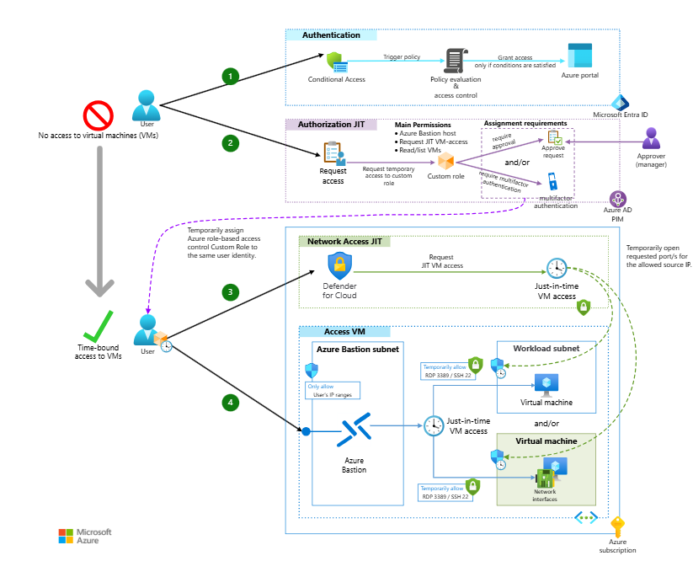

4.1 Architecture Description
The proposed solution implements a defense-in-depth architecture, where multiple independent security controls protect VM access. Access is granted only when:
- User identity is verified through strong authentication
- Access justification is valid and approved
- Permissions are time-bound and least-privileged
- Network and identity controls are enforced simultaneously
The primary goal is to minimize the VM attack surface while enabling legitimate administrative access when required.

5. Logical Architecture Components

5.1 Identity and Access Layer
- Microsoft Entra ID (Azure AD) for centralized identity management
- Multi-Factor Authentication (MFA) for strong authentication
- Conditional Access policies based on device compliance, user risk, and location
This layer ensures that only authenticated, authorized, and compliant users can initiate VM access.

5.2 Privileged Access Management Layer
- Microsoft Entra Privileged Identity Management (PIM)
- Just-in-time elevation of privileged roles
- Approval-based and time-bound access workflows
This eliminates standing administrative privileges and enforces controlled elevation only when required.

5.3 Network Access Layer
- Azure Bastion for secure RDP/SSH access without public IP exposure
- Network Security Groups (NSGs) for inbound and outbound traffic control
- Default deny model for inbound management traffic
Virtual machines are not directly accessible from the internet, significantly reducing exposure to attacks.

5.4 Just-In-Time (JIT) VM Access Layer
- Microsoft Defender for Cloud – JIT VM Access
- Temporary opening of RDP/SSH ports only upon approval
- Automatic port re-locking after access expiration
This prevents persistent exposure of management ports and mitigates brute-force attempts.

5.5 Authorization and Governance Layer
- Azure Role-Based Access Control (RBAC) with custom roles
- Enforced separation of duties between administrators and operators
- Strict adherence to the principle of least privilege
Each user receives only the permissions required to perform assigned tasks.

5.6 Secrets and Credential Management
- Azure Key Vault for secure storage of VM local credentials and secrets
- Centralized secret lifecycle management and rotation

6. Cloud Center of Excellence (CCoE) Enablement Model
The CCoE uses this reference architecture to:
- Define standardized and approved VM access patterns
- Enforce enterprise security and governance controls
- Provide reusable templates, policies, and landing-zone integrations
This supports consistent and scalable Azure governance across the organization.

7. Reusability and Scalability
- Reusable across multiple subscriptions and regions
- Scalable for enterprise and CSP-managed environments
- Fully compatible with Azure Landing Zones and hub-and-spoke networking models

8. Conclusion
The Multilayered Protection Reference Architecture for Azure Virtual Machines provides a secure, able, and Microsoft-aligned framework for managing VM access. It enables organizations to protect critical infrastructure while maintaining operational flexibility, governance consistency, and security excellence.

